Session 10

- Create two tables: Influencers (id, name) and Collaborations (id, influencer1_id, influencer2_id, collab_date). Write a SQL FULL JOIN query to list all influencers and show their collaboration partner names if any, including influencers with no collaborations.
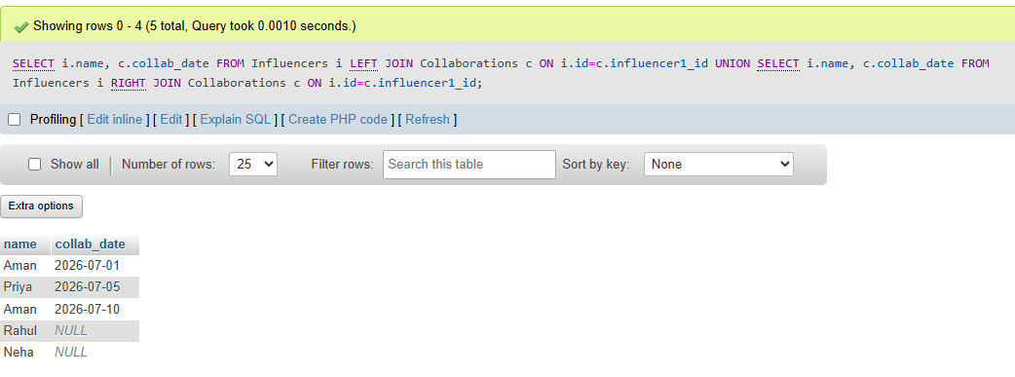

- Using a SELF JOIN, write a query on a table called Playlists (id, user_id, playlist_name, parent_playlist_id) to display each playlist alongside its parent playlist name, similar to how Spotify shows nested playlists.<br><br><em><strong>Hint:</strong> Join Playlists with itself on parent_playlist_id = id.</em>.

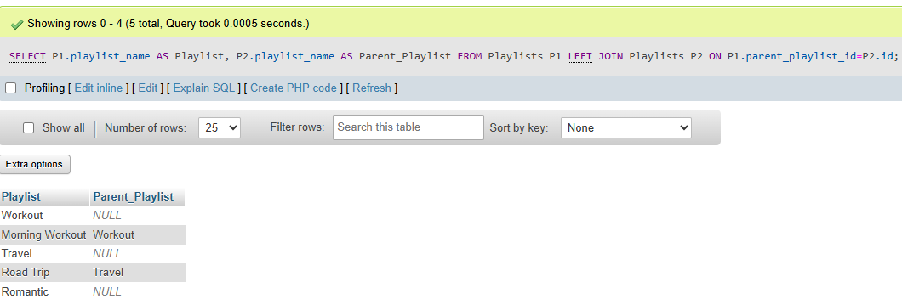

- Given three tables: Users (id, username), Orders (id, user_id, order_date), and Payments (id, order_id, amount), write a SQL query using multiple JOINs to display each username, their order date, and payment amount, showing all users even if they have no orders or payments.

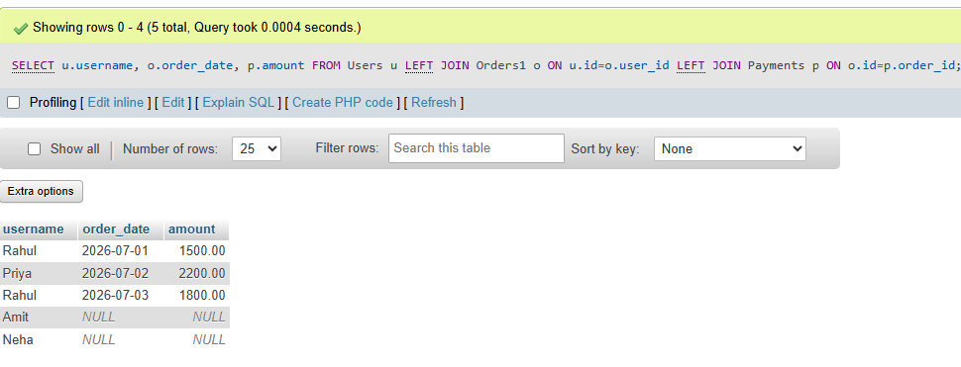

- You notice that your JOIN query between Zomato's Restaurants and Reviews tables is returning duplicate rows for some restaurants. Modify your query to eliminate duplicates and explain in one line why the duplicates were happening.<br><br><em><strong>Hint:</strong> Use DISTINCT or GROUP BY and consider the relationship between restaurants and reviews.</em>

Doubt

- Write two different JOIN queries on a Products and Categories table (like Flipkart) to list all products with their category names, but use different join conditions in each. Briefly explain which join condition is more efficient and why.
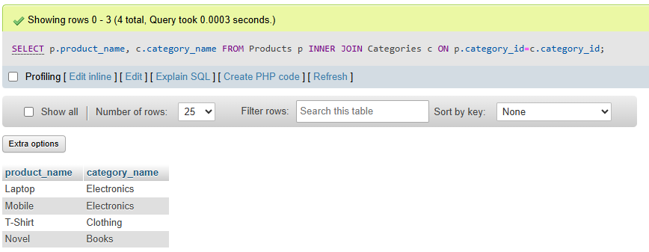

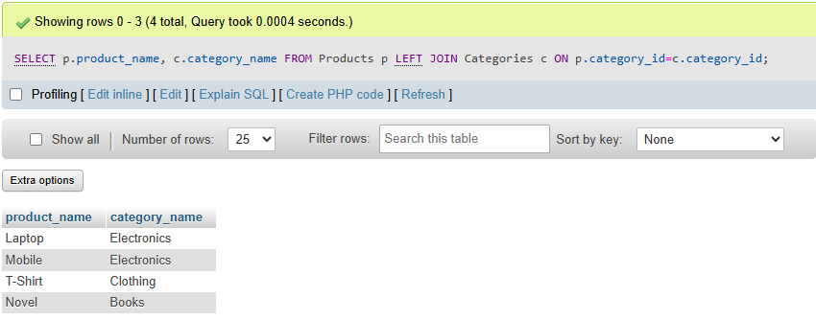

Which is more efficient?
- INNER JOIN is more efficient when you only need matching records.
- LEFT JOIN is used when you want all products, even if some have no matching category.

